Helix AI - An ML and DL Tool
As a part of the subject
22AIE213 Machine Learning
Submitted by
GIRI PRASATH R (CB.EN.U4AIE22122)
HARISH VIJAY V (CB.EN.U4AIE22124)
SAMHITHA S (CB.EN.U4AIE22150)
VAISHNAVI VENKAT (CB.EN.U4AIE22158)
IPPATAPU VENKATA SRICHANDRA (CB.EN.U4AIE22165)

in partial fulfillment for the award of the degree of

BACHELOR OF TECHNOLOGY
IN
CSE(AI)



Centre for Computational Engineering and Networking
AMRITA SCHOOL OF ARTIFICIAL INTELLIGENCE
AMRITA VISHWA VIDYAPEETHAM
COIMBATORE – 641 112 (INDIA)
JUNE – 2024

AMRITA SCHOOL OF ARTIFICIAL INTELLIGENCE
AMRITA VISHWA VIDYAPEETHAM
COIMBATORE - 641 112

BONAFIDE CERTIFICATE
This is to certify that the thesis entitled “ Helix AI - An ML and DL Tool ” submitted by Giri Prasath R(CB.EN.U4AIE22122), Harish Vijay V (CB.EN.U4AIE22124),Samhitha S(CB.EN.U4AIE22150),Vaishnavi Venkat (CB.EN.U4AIE22158), Ippatapu Venkata Srichandra(CB.EN.U4AIE22165) for the award of the Degree of Bachelor of Technology in the “CSE(AI) ” is a Bonafede record of the work carried out by her under our guidance and supervision at Amrita School of Artificial Intelligence, Coimbatore.

Project Guide:
Dr. Abhishek S.

Submitted for the university examination held on 04/06/2024.

AMRITA SCHOOL OF ARTIFICIAL INTELLIGENCE
AMRITA VISHWA VIDYAPEETHAM
COIMBATORE - 641 112

DECLARATION
We, Giri Prasath R(CB.EN.U4AIE22122), Harish Vijay V (CB.EN.U4AIE22124),Samhitha S(CB.EN.U4AIE22150),Vaishnavi Venkat (CB.EN.U4AIE22158), Ippatapu Venkata Srichandra (CB.EN.U4AIE22165) hereby declare that this is entitled “Helix AI - An ML and DL Tool ”, is the record of the original work done by us under the guidance of Dr. Abhishek S, Assistant Professor, Centre for Computational Engineering and Networking, Amrita School of Artificial Intelligence, Coimbatore. To, the best of our knowledge this work has not formed the basis for the award of any degree/diploma/ associate ship/fellowship/or a similar award to any candidate in any University.

Place: Coimbatore.
Date: 04-06-2024.

Acknowledgement

We,Giri Prasath R(CB.EN.U4AIE22122), Harish Vijay V (CB.EN.U4AIE22124),Samhitha S(CB.EN.U4AIE22150),Vaishnavi Venkat (CB.EN.U4AIE22158), Ippatapu Venkata Srichandra(CB.EN.U4AIE22165) hereby declare that this thesis entitled “ Helix AI - An ML and DL Tool”, is the record of the original work done by me under the guidance of Dr. Abhishek S, Assistant Professor, Centre for Computational Engineering and Networking, Amrita School of Artificial Intelligence, Coimbatore. To the best of my knowledge this work has not formed the basis for the award of any degree/diploma/ associate ship/fellowship/or a similar award to any candidate in any University.

Contents
ABSTRACT:
INTRODUCTION:
METHODOLOGY:
BRUTE FORCE METHOD:
MATHEMATICAL APPROACH:
MAX FLOW ALGORITHM:
FORD-FULKERSON METHOD:
EDMONDS -KARP ALGORITHM:
CAPACITY SCALING ALGORITHM:
DINIC’S ALGORITHM:
PUSH RELABLE ALGORITHM:
CONCLUSTION:

Figure 1

ABSTRACT

Helix AI is an Machine Learning and Deep learning Application that streamlines the entire machine learning process, from data preprocessing to model evaluation, making it accessible to all users. By simply inputting a dataset and choosing a model, Helix AI takes care of handling outliers, visualizing data, running models, and assessing performance. It generates an easy-to-understand HTML report summarizing all findings. What sets Helix AI apart is its integration of LLM (Language Model) technology, which extracts valuable insights from the report, enhancing understanding and decision-making. It offers a wide range of tasks, including supervised and unsupervised learning, as well as NLP tasks powered by BERT. Additionally, it employs advanced techniques like neural networks and genetic algorithms for feature selection in supervised algorithms. Helix AI empowers users to leverage the power of machine learning without the need for specialized expertise.

INTRODUCTION

In machine learning and deep learning algorithms, the steps like the preprocessing it involves cleaning and transforming raw data to improve model performance. Visualizations aid in understanding data distributions, patterns, and relationships, crucial for feature selection and model interpretation. These steps are essential precursors to training models effectively and deriving meaningful insights from data.
1.1 Preprocessing
Preprocessing step is plays crucial role in machine learning or deep learning.it helps in cleaning and transforming raw data into a format suitable for analysis by machine learning algorithms.
There are different types of preprocessing steps:

- Handling Missing Values: Identify and handle missing values in the dataset. Techniques include imputation (replacing missing values with a calculated estimate) or removal of rows or columns with missing values.
- Dealing with Outliers: Outliers can skew the distribution of data and affect model performance. Techniques such as trimming (removing extreme values), winsorization (replacing extreme values with less extreme ones), or transforming data (e.g., log transformation) can mitigate the impact of outliers.
- Feature Scaling: Standardize or normalize features to ensure that they have a similar scale. Common scaling techniques include Min-Max scaling and Z-score normalization. This prevents features with larger scales from dominating the learning process.
- Encoding Categorical Variables: Convert categorical variables into a numerical format that machine learning algorithms can understand. This can be done using techniques like one-hot encoding, label encoding, or target encoding.

- Feature Engineering: Create new features or transform existing ones to improve model performance. Feature engineering techniques include polynomial features, interaction terms, binning, and dimensionality reduction techniques like PCA (Principal Component Analysis).
- Handling Imbalanced Data: Address class imbalance issues in classification tasks by resampling techniques such as oversampling (duplicating minority class samples) or undersampling (removing majority class samples).

1.2 Visualisation

Visualizations in machine learning serve multiple purposes, aiding in data exploration, model evaluation, and result interpretation.
There are different types of visualisations and they are:
1)Histograms: It is used to display the distribution of numerical data by dividing it into bins and plotting the frequency of observations in each bin.
2)Scatter Plots: It show the relationship between two numerical variables, with each data point represented as a dot on the plot.
3)Box Plots: It Illustrate the distribution of numerical data through quartiles, highlighting outliers and variability in the dataset.
4)Correlation Heatmaps: It is used to visualize the correlation between numerical variables using color gradients, helping identify correlated features.
5)Pair Plots: It is used to plot pairwise relationships between numerical variables in a dataset, often with scatter plots or histograms, facilitating data exploration.
6)ROC Curves: It is used to plot the true positive rate against the false positive rate to evaluate the performance of binary classification models across different threshold values.
7) Precision-Recall Curves: It is used to Illustrate the trade-off between precision and recall for classification models, aiding in model evaluation, particularly for imbalanced datasets.
8)Confusion Matrices: It is used to display the performance of a classification model by summarizing the counts of true positive, true negative, false positive, and false negative predictions.

1.3 Supervised Learning
1.3.1 Regression
Linear Regression
It is a approach in which it assumes a linear relationship between the input variables and the output variable. It is suitable for datasets with linear trends and provides interpretable coefficients.
Ridge Regression
It is a variant of linear regression that includes L2 regularization to prevent overfitting. It is useful for multicollinearity issues where independent variables are highly correlated.
Lasso Regression
It is similar to Ridge Regression but uses L1 regularization, which can shrink some coefficients to zero, effectively performing feature selection.It is ideal for sparse datasets with many irrelevant features.
ElasticNet Regression
It is a combines L1 and L2 regularization techniques, balancing between Ridge and Lasso.It is a effective for datasets with multiple features where feature selection and multicollinearity are concerns.
Bayesian Ridge Regression
In this it incorporates Bayesian inference, providing probabilistic predictions and robustness to overfitting. It is useful when uncertainty estimation is crucial.
RANSAC Regression
It is a robust regression technique that iteratively fits a model to random subsets of the data, focusing on inliers while excluding outliers.It is ideal for datasets with significant outliers.

Support Vector Regression (SVR)
It is uses support vector machines to perform regression, suitable for both linear and non-linear relationships. It is effective for high-dimensional spaces and provides flexibility with kernel functions.
Decision Tree Regression
It is a non-linear model that splits the data into subsets based on feature values, forming a tree structure. It is suitable for capturing complex interactions between features.
Random Forest Regression
It is an ensemble method that combines multiple decision trees to improve accuracy and reduce overfitting. It is robust to noise and handles a large number of features well.
AdaBoost Regression
It is an ensemble technique that combines weak learners, typically decision trees, to form a strong predictor. It focuses on reducing bias and can improve the performance of simple models.
Gradient Boosting Regression
It an iterative boosting method that builds models sequentially, each correcting the errors of its predecessor. It is a highly accurate and effective for complex datasets.
Multilayer Perceptron (MLP) Regression
It is a type of neural network suitable for capturing non-linear relationships. It is a requires careful tuning and sufficient data to prevent overfitting.
K-Nearest Neighbors (KNN) Regression
It is a simple, instance-based learning method that predicts based on the average of the nearest neighbors. It is effective for small datasets and non-linear relationships but can be computationally intensive for large datasets.
Gaussian Process Regression
It is a non-parametric, probabilistic model that provides flexible predictions and uncertainty estimates.It is suitable for small datasets with complex patterns, but computationally expensive for large datasets.

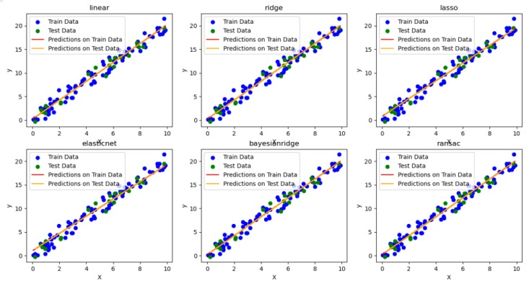
Fig-1 Regression Plots across different Models

1.3.2 Classification
Support Vector Machine (SVM)
It is a powerful classification algorithm that finds the optimal hyperplane which maximizes the margin between different classes. It is effective in high-dimensional spaces and is versatile with different kernel functions like linear, polynomial, and radial basis function (RBF).
Decision Tree
It is a decision Tree classifier is a non-linear model that splits the data into subsets based on feature values, forming a tree-like structure. It is easy to interpret and can handle both numerical and categorical data.
Random Forest
It is an ensemble learning method that constructs multiple decision trees during training and outputs the mode of their predictions. It improves accuracy and reduces overfitting compared to individual decision trees.
K-Nearest Neighbors (KNN)
It is KNN is a simple, instance-based learning algorithm that classifies a sample based on the majority class among its k-nearest neighbors in the feature space. It is intuitive and works well with small to medium-sized datasets.
Multilayer Perceptron (MLP)
It is a MLP is a type of feedforward artificial neural network consisting of multiple layers of neurons. It can model complex relationships in the data and is suited for tasks where non-linear patterns need to be captured.
AdaBoost
It is adaBoost (Adaptive Boosting) is an ensemble technique that combines multiple weak classifiers to form a strong classifier. It adjusts the weights of incorrectly classified instances, focusing more on difficult cases in subsequent iterations.
Gradient Boosting
It is gradient Boosting is another ensemble technique that builds models sequentially, where each new model corrects the errors of the previous ones. It uses gradient descent to minimize the loss function and is effective for both classification and regression tasks.
Gaussian Naive Bayes
It is gaussian Naive Bayes is a probabilistic classifier based on Bayes' theorem, assuming that the features follow a Gaussian (normal) distribution. It is simple, fast, and effective, especially for high-dimensional data and small datasets.

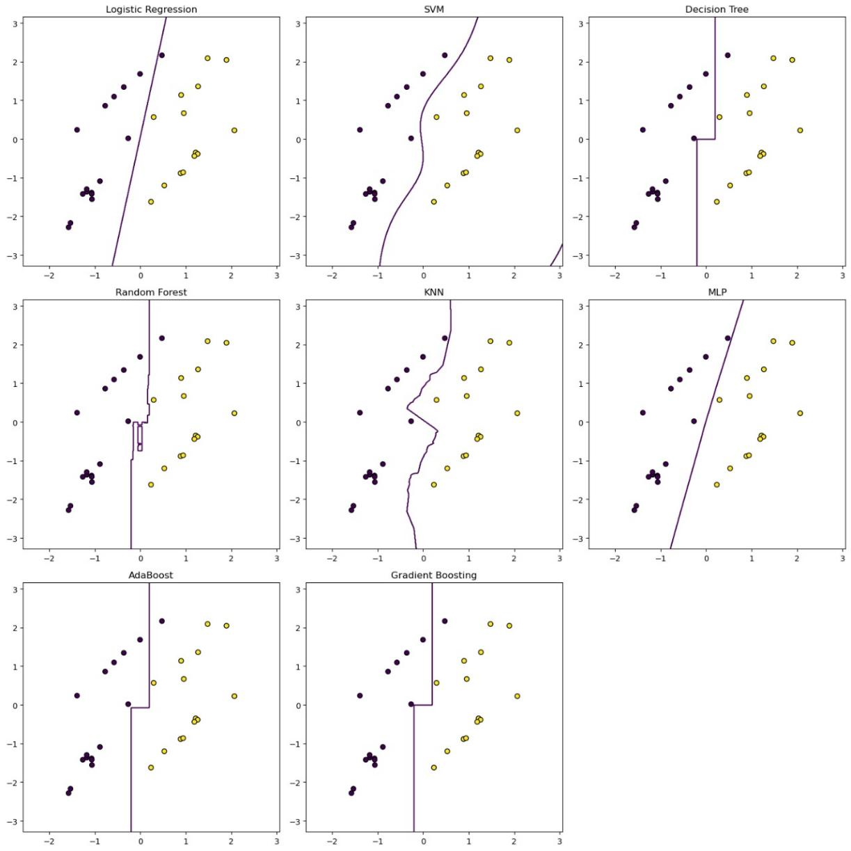
Fig-2 Classification Plots across different Models

1.4 Unsupervised Learning
Unsupervised learning, especially clustering, groups data points based on similarities without needing labeled data, aiding exploratory analysis and pattern recognition. This report covers key clustering algorithms: K-Means, DBSCAN, Agglomerative Clustering, and Gaussian Mixture Models (GMM), each suited for different data types and tasks.
They are as follows:

K-Means Clustering:
K-means algorithm partitions data into k clusters, minimizing the variance within each cluster.It is simple and efficient for large datasets, easy to implement.The main disadvantage is to that specifying the number of clusters (k) in advance, sensitive to initial centroid placement and outliers.
DBSCAN (Density-Based Spatial Clustering of Applications with Noise)
It groups data points based on density, identifying clusters of varying shapes and sizes while handling noise.The main advantage is does not require specifying the number of clusters, robust to outliers and can find arbitrarily shaped clusters.The disadvantages is that the performance can be sensitive to parameter settings (epsilon and minimum samples).
Agglomerative Clustering
It is hierarchical clustering method that builds clusters by recursively merging or splitting them based on a linkage criterion.It does not require specifying the number of clusters in advance, provides a dendrogram for visualizing the cluster hierarchy.Thedisadvantages is computationally intensive for large datasets, choice of linkage criterion can affect results.
Gaussian Mixture Models (GMM)
The GMM assumes data is generated from a mixture of several Gaussian distributions, estimating the parameters using the Expectation-Maximization (EM) algorithm.The main advantages can model complex cluster shapes and provides probabilistic cluster memberships.The disadvantages requires specifying the number of components, can be sensitive to initialization and computationally expensive.

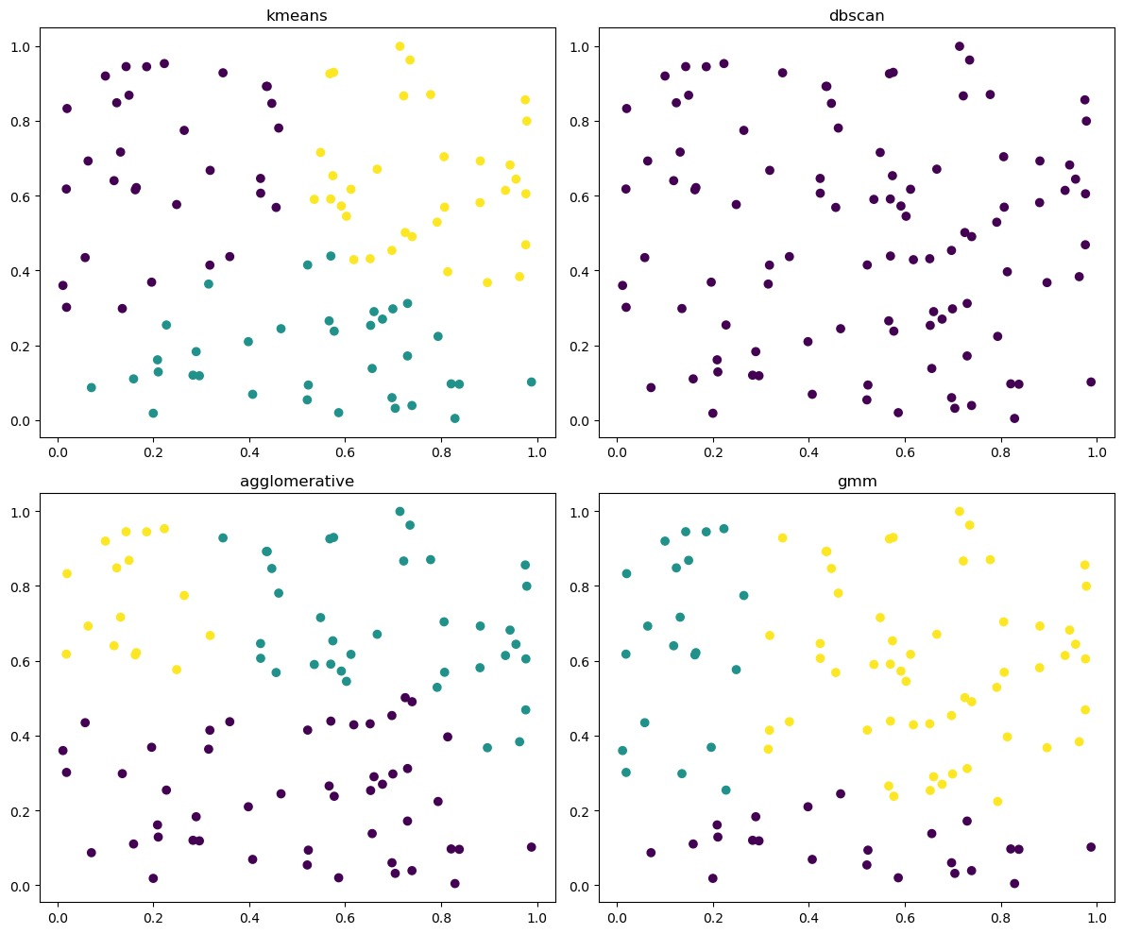
Fig-3 Clustering Plots across different Models

1.5 Genetic Algorithm for Feature Selection
Genetic algorithms (GAs) are powerful optimization techniques inspired by the process of natural selection. They are particularly effective for solving complex problems in machine learning, such as feature selection and hyperparameter tuning. GAs work by evolving a population of candidate solutions over several generations, using operations such as selection, crossover, and mutation to improve the quality of solutions. This report explores the application of GAs in optimizing machine learning models, with a focus on feature selection for regression tasks.
The important points are:
Nature-Inspired Optimization
Genetic algorithms simulate the process of evolution, using mechanisms like selection, crossover, and mutation to evolve solutions.
Population-Based Search
They maintain a population of potential solutions, promoting diversity and enhancing the search for optimal solutions.
Selection
The fittest individuals are selected to pass their genes to the next generation, ensuring survival of the best traits.
Crossover
Genetic crossover combines parts of two parent solutions to create new offspring, facilitating the exchange of good traits.
Mutation
Random mutations introduce variability, helping to explore new regions of the solution space and avoid local optima.
Fitness Function
The fitness function evaluates the quality of solutions, guiding the evolution process towards better solutions.
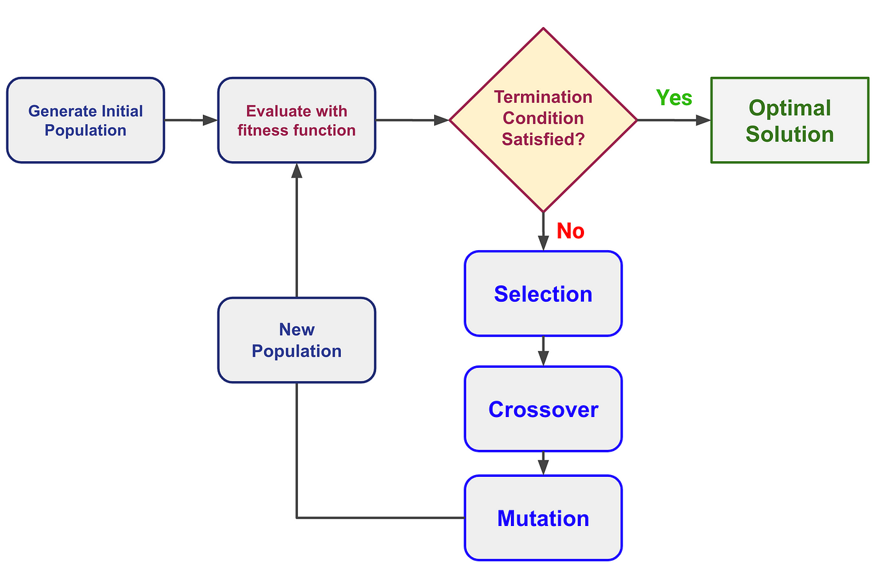
Fig-4 The genetic algorithm work flow

1.5 BERT Model

BERT (Bidirectional Encoder Representations from Transformers) is a state-of-the-art natural language processing model that has significantly advanced the field of sentiment analysis. Unlike traditional models, BERT employs a bidirectional approach, meaning it considers the context from both the left and right sides of a word in a sentence. This deep contextual understanding allows BERT to capture nuanced sentiments in text, making it exceptionally effective for tasks like sentiment analysis. When applied to sentiment analysis, BERT can accurately discern the sentiment of a piece of text, whether it's positive, negative, or neutral, by leveraging its deep learning architecture and extensive pre-training on diverse text corpora. This capability makes BERT a powerful tool for applications such as social media monitoring, customer feedback analysis, and market research, providing precise and reliable sentiment insights.

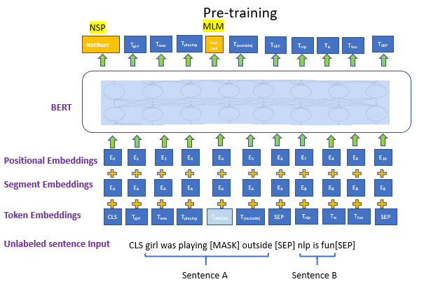

1.6 Artifical Neural Network

Artificial Neural Networks (ANNs) are computational models inspired by the structure and function of the human brain. They consist of interconnected nodes organized in layers, where each node represents a neuron. ANNs learn from data through a process called training, where they adjust the weights of connections between neurons to minimize errors in predictions. ANNs are capable of learning complex patterns and relationships in data, making them valuable for tasks like classification, regression, and pattern recognition. With their ability to generalize from training data to unseen examples, ANNs have become a cornerstone of modern machine learning, powering applications ranging from image and speech recognition to natural language processing and autonomous vehicles.

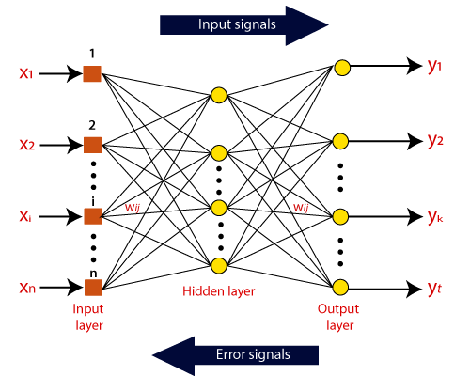

Methodology
